PLSQL Task 21.11.2024

1.Write the Store procedure that returns the details of employees joined in a specific year

delimiter //

create procedure get_specificYearDatails(in get_year int)

begin

select * from emp where year(doj) = get_year;

end; //

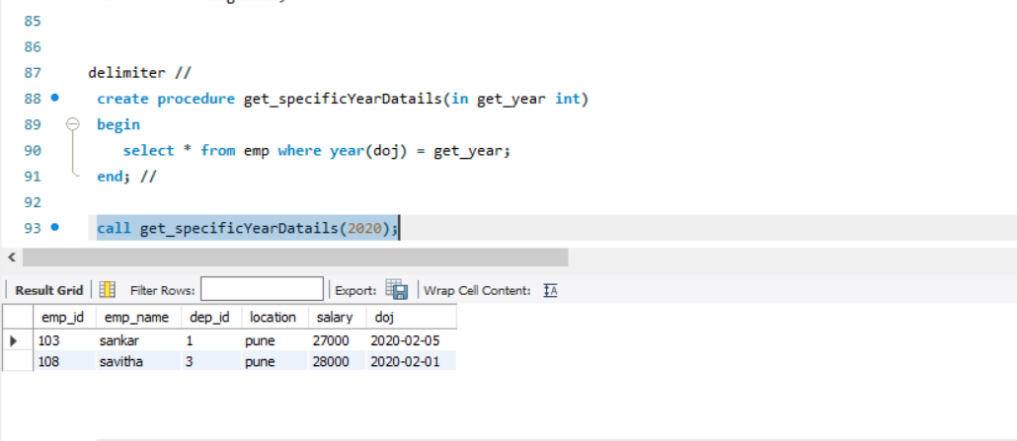

2.Create a View that display the details of senior most person

Create view senior_view as

select * from emp order by doj asc limit 1;

select * from senior_view;

